PHYS 102 Purchase Order

Note: Every lab lasts two weeks each.

# Material used for more than one lab:

If there are no EQ numbers below, it’s because I couldn’t find them on the sky database.

* Resistors
  + 10 $MΩ$: 15 + spares (Lab 1)
  + 400 $Ω$: 15 + spares (Lab 1)
  + 10 $Ω$: ~50 (Lab 2) SN3139 (none in stock based on sky database)
  + 50 $Ω$: ~100 (Lab 2) SN3156 (none in stock based on sky database)
  + 100 $Ω$: ~50 (Lab 2) SN3163 (none in stock based on sky database)
  + 200 $Ω$:~30 (Lab 2) SN3170 (none in stock based on sky database)
  + 500 $Ω$:~30 (Lab 2) SN3180 (none in stock based on sky database)
  + 1000 $Ω$:~10 (Lab 2) SN3187 (200 in stock)
* Capacitors
  + 10 $μF$:~120 (Lab 2) SN2095, SN2130 (none in stock based on sky database)
  + 50 $μF$:~50 (Lab 2) SN2103 (none in stock based on sky database)
  + 100 $μF$:~20 (Lab 2) SN2173, SN2174 (40 in stock)
  + 200 $μF$:~10 (Lab 2) SN2111, SN2134 (none in stock based on sky database)
* Multimeter
  + 5 communal multimeters that can measure capacitance (Lab 1 and 2)

# Lab 1: Capacitance (NEW)

* Arduino (already ordered)
  + 15 + spares
* Aluminum plates
  + <https://www.mcmaster.com/89015k82>
  + 6061 Aluminum Sheet, 0.04" Thick, 48" x 48", 89015K82
  + Need to purchase 5 sheets to be able to build 20 setups (need 15 + spares).
* Plastic sheets
  + Winnable Poly Sheet protectors (each pack comes with 10 sleeves)
  + <http://www.winnable.com/accessories/copy-of-slant-binder-pocket-zp7wr-s7xer> (can be purchased elsewhere)
  + Need to purchase 6 packs: need 3 sleeves per team so roughly 1 pack per 3 stations, there are 5 stations so at least 5 packs (+ spares). Each sleeve needs to be cut in half to make two sheets (so 6 sheets per team).
  + 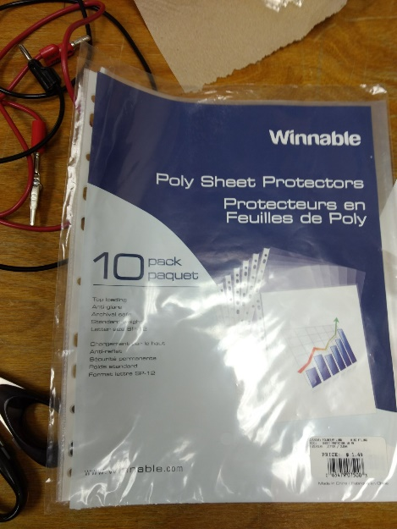
* Utility cases
  + Steve never sent me the link of the online order, but here’s a picture of the box followed by the circuit that we need connected underneath (connected to the Arduino). The red comments are associated with the next picture, the previous connection for the Arduino.

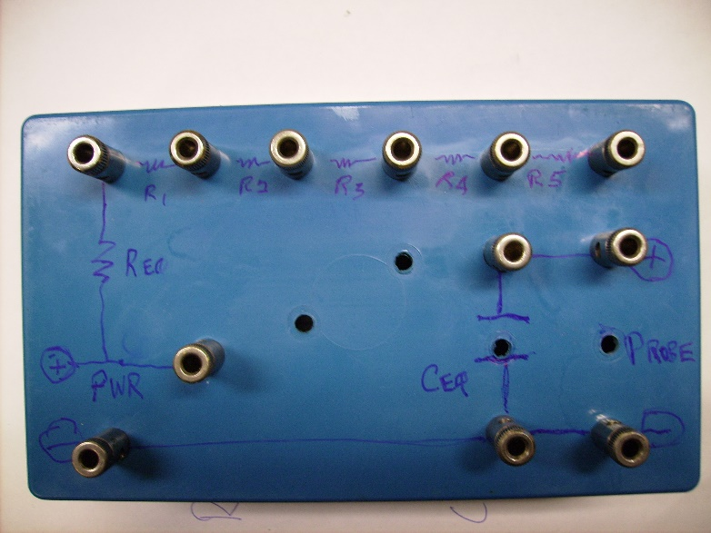

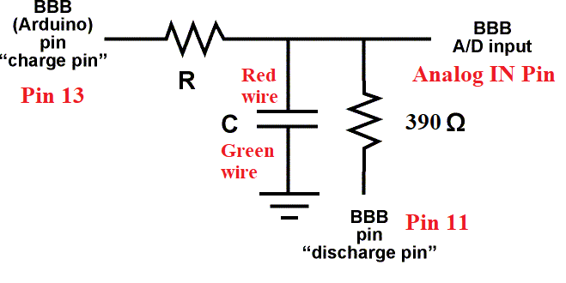

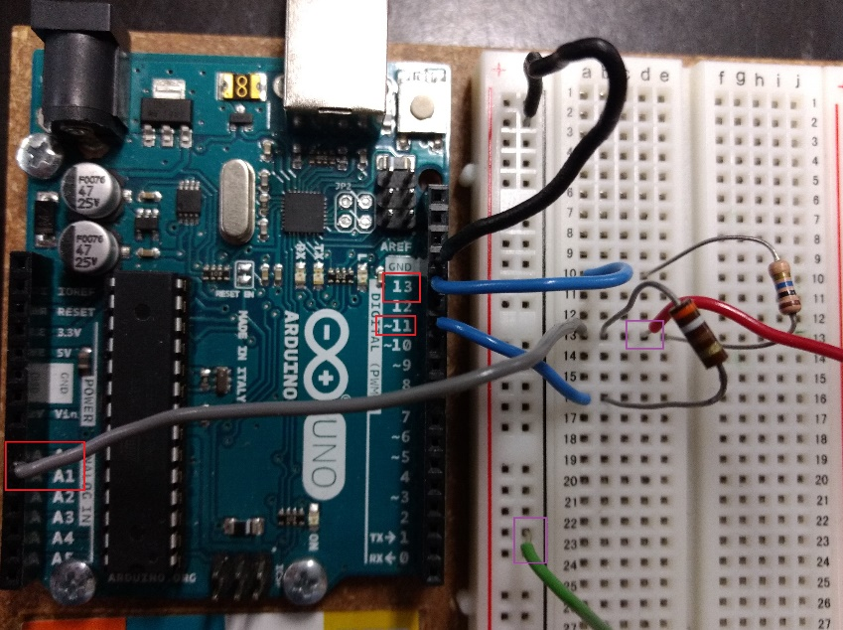

* Resistors
  + For each Arduino/utility case unit, we need one 400 $Ω$ and one $10 MΩ$ resistor as shown above
* Multimeter (see above)

# Lab 2: RC Circuit (Based on EN0053)

New material

* Bread boards
  + 3 x 3 ½ in
  + 15 + spares
* Resistors (see above)
* Capacitors (see above)
* Multimeter (see above)

Equipment to be removed from the current EN0053:

* On Sky, there are oscilloscopes listed, but we won’t need any of them
  + EQ30003-3006, 3013, 3014, 3442-3445, 3438, 3439, 3440, 0303, 5398, 3441, 0542, 0541, 0543

# INCOMPLETE Lab 3: Magnetism